20XX-01-XXXX

[Heart-rate/health monitors using single camera](https://www.sae.org/servlets/techpapers/paperHome.do?evtSchedGenNum=255402&evtName=17SS-0538&prodGrpCd=PPRES&idTyp=paper)

Author, co-author (Do NOT enter this information. It will be pulled from participant tab in MyTechZone)

Affiliation (Do NOT enter this information. It will be pulled from participant tab in MyTechZone)

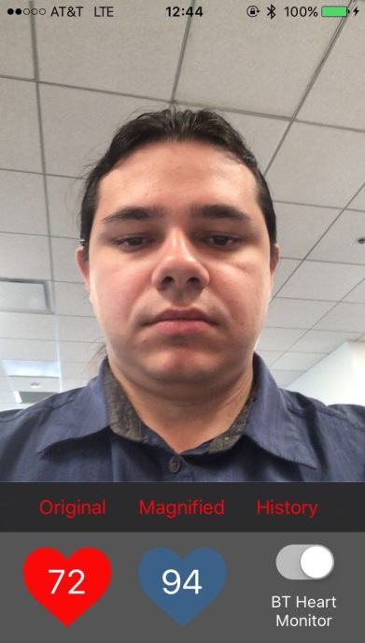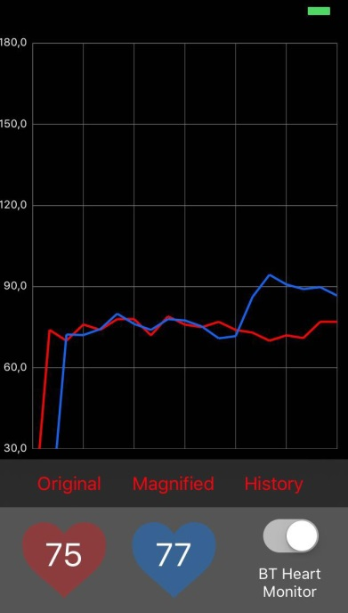

Abstract

Heart rate is one of the most important biological features for health information. Most of the state-of-the-art heart rate monitoring systems relies on invasive technologies that require physical contact with the user. In this paper, we propose a non-invasive technology based on a single camera to measure the user’s heart rate in real time. The algorithm estimates the heart rate based on facial color changes. The input is a series of video frames with the automatically detected face of the user. A Gaussian pyramid spatial filter is applied on the inputs to obtain a down sampled high signal-to-noise ratio images. The signal difference between the blue and red channels is calculated and a temporal Fourier transform is applied to the video to get the signal spectrum. Next, a temporal band-pass filter is applied on the transformed signal in the frequency domain to extract the frequency band of heart beats. The heart rate is then estimated by finding the dominant frequency in the Fourier domain. Further, an inverse Fourier transform is used on the spectrum to convert the signal back to the time domain. After scaling, the amplified signal is added to the input image to magnify the subtle facial color change that is caused by the heartbeat. We implement on an iPhone 5s using the front facing camera and demonstrate that it has ~1.4 bpm error when compared to a standard hearth rate monitor.

Figure illustration of image from the user developed user interface illustrating the heart rate computation. Image form the user, on the left side. On the right side, comparison of the hearth rate computation between a standard hearth monitor (in red) and our proposed algorithm based on change magnification (in blue).

Introduction

Heart disease is the leading cause of death for both men and women. In the United States around 610,000 people die because a cardiovascular problem that is 25% percent of every death registered every year [1]. This kind of medical conditions are a big concern due to the associated risk with vehicle accidents. When drivers are affected, heart diseases such as strokes can cause a fatal accident not only for the chauffeur suffering it, but for the surrounding vehicles or persons. Similarly, passengers such as infants can get affected for problems such as the Sudden infant Death Syndrome (SIDS), one of the leading causes of death in babies from 1 month to 1 year of age [2] that causes to stop breathing. Health monitoring systems can potentially help to reduce these accidents by detecting and anticipating this type of problem early enough to take a safe action and avoid a potential fatal accident. Over the last years, heart rate monitors (HRMs) are becoming widely used in a variety of day to day activities and sports. Data from HRMs are used either from prognosis, for prediction of future diseases or potential health problems, or diagnosis, where a current problem can be detected based in present information. HRM devices can be used to measure the Heart rate variability (HRV) which is correlated with emotions, stress, or physical malfunctions such as illness or strokes [3]. This information can be used to identify a potential hearth disease problem or even a stroke before it happens [4]. Furthermore, all the historic hearth rate information can be used to indicate other health metrics to early detect other health problems. One of the main problems on current HRMs is that they do not offer portability, or it is difficult to maintain a system working all the time in places like a car. Most of the state-of-the-art heart rate monitoring systems relies on invasive technologies that require physical contact with the user. In this paper, we propose a non-invasive technology based on a single camera to measure the user’s heart rate in real time. The algorithm estimates the heart rate based on facial color changes. We show that we can accurately compute the hearth rate of a person without touch. Our proposed algorithm is based on analysis in the frequency domain implemented in a portable device such as an smartphone with an integrated camera. We have demonstrated that our implementation achieves on average ~1.4 bpm error when compared to a standard hearth rate monitors.

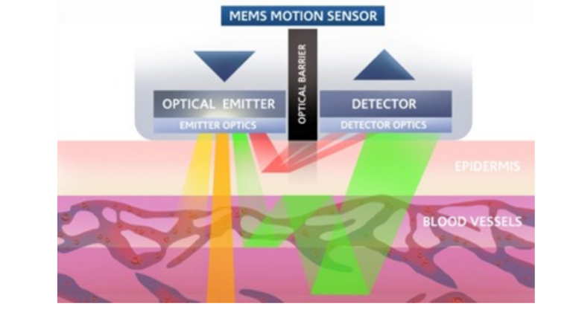Figure illustration of photoplesthysmography (PPG) application example. A motion sensor is placed on the wrist of a user, such sensor has an optical emitter that actively illuminates a region of interest. The optical detector captures the color variation which is correlated to heart rate in bpm.

Background

Commonly heart rate is expressed as beats per minute (bpm), i.e. the number of heartbeats per unit of time. Bpm are currently extracted using different methods such as electrocardiograms (ECG), pulse studies or sphygmology, by measuring the oxygen level on the blood (oxymetry), etc. Although very accurate, all of such methods require physical contact with human body which can be uncomfortable or impractical if the monitoring is applying over extended periods of time. In addition, these methods do not offer portability making its usage impractical for applications that involve movement or activities such as driving, or exercise. The use of Optical health monitoring (OHMs) it is dated since the late 1800’s, blood flood monitoring was measured by having people hold their hand up to a candle in a dark room to see the vascular structure and blood flow. In the 21st Century this concept has been revolutionized for new use cases and has helped to the current pinnacle of wearable technologies that allow measuring heart rate and other health metrics in a more portable fashion. This state-of-the-art technology relies on photoplesthysmography (PPG) to measure the heart rate [5]. Essentially, this technique is based on the amount of color transitions that occurs on the skin on your wrist but it requires an optical emitter. However this technique offers more flexibility compared with the previous methods, it does require wearing special equipment for each user, and in patients such as infants the use of PPGs becomes rather complicated.

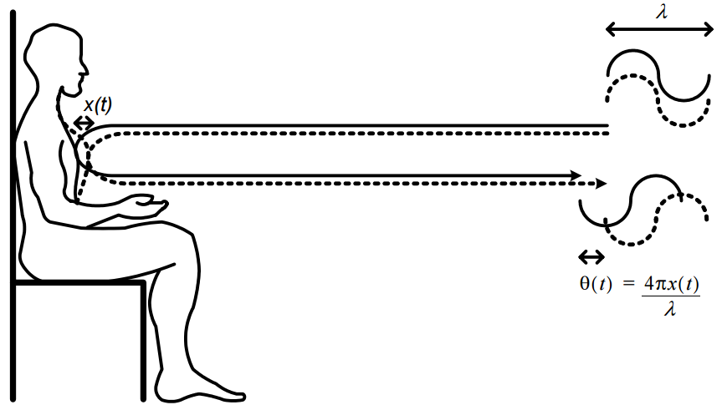Clearly non-contact techniques are very necessary as they can help several areas such as vehicle driving monitoring, PC workspace, sports monitoring, etc, where measuring vital signs can help to avoid an accident. Recent advantages in Doppler radar sensor allows for noncontact health monitoring for different applications, such as baby monitoring where electrodes or chest-strap monitors causes discomfort or are difficult to apply [6] [7]. Other non-invasive technologies use the fact that that wireless signals are affected by motion in the environment, including chest movements due to inhaling and exhaling and skin vibrations due to heartbeats [8] (See Figure 3).Other similar non-contact technologies have been developed based on wireless signals for smart environments such as Vital-Radio [9]. Although these technologies have a lot of potential and have shown to be very accurate, in practice its implementation

Figure Image from [7], the phase of the reflected signal of the radar, θ is directly proportional to the chest motion x(t), and is scaled by the wavelength, λ to measure the hearth rate.

requires special equipment that it is currently not easily available to everybody.

Computer vision technologies can also be used for health monitoring. One of the first works related to non-contact rate calculation was made by [10], where breath rate from human faces images using thermal cameras was measured. Similarly, infrared cameras were used by [11] that correlated thermal variations on the blood flood with bpm. However infrared cameras are not necessary pervasive technologies. The evolution of ubiquitous technologies such as cameras in smart phones offers an incredible opportunity for health monitoring using computer vision techniques. Video magnification is one of the main approaches to compute heart rates based on RGB cameras. Video magnification was introduced by [12] as the task of amplifying and visualizing subtle variations on images sequences. Such variations can be magnified to reveal meaningful small variations that can be correlated with different phenomena such as health metrics. Currently, two main methodologies are derived from this technique, named Lagrangian [12] which magnify motion changes, and Eulerian which magnifies motion [13] as wells as color changes [14]. Most recently [15] presented a layer-based video magnification approach that amplified small and large motions. In fact, we have developed our system inspired in the Eulerian methods where small temporal variations are analyzed. The system can compute the hearth rate of a person without touching accurately. Our proposed algorithm is based on analyzing these small variations on image pixels and then extracting an appropriate frequency correlated to the heart rates. We implemented our method in an application from IOS in an iPhone 5s and evaluated the accuracy of the system compared with a chest-trap monitor.

Method

* Background of method and overall description of the system
* Data-preparation/pre-processing
* Face detection
* Down-sampling
* Signal difference computation and hearth rate calculation.
* TODO: Add this description in an algorithm form.

The blood vessels are fully distributed underneath the human skin, especially the facial part. The cardiac cycle causes the subtle color change by these vessels periodically. By observing this invisible change, the period can be measured to calculate the heart rate. The challenge is how to observe this change that is invisible to the naked eye. Here we present the solution of amplifying this subtle change. The steps for computing the heart rate are described as follows:

1. Gaussian Pyramids: Given a sequential set of image samples, a Gaussian Pyramid is created for each image. By choosing the low resolution image after Gaussian blur, the high frequency information is filtered in the spatial domain. Any other processing methods can be used in this step.
2. Temporal Filter: Going deeper into the pixel level of Gaussian blur image, a temporal filter is applied on every pixel sequence. A Discrete Fourier Transform (DFT) is applied to transform the signal from the time domain to the frequency domain.
3. Extracting the heart rate: Then, a band pass filter with pass band from 0.667Hz to 3Hz (40 bpm to 180bpm) is applied to extract the heart beat band signal out from the raw signal.
4. Heart beats in the time domain: The signal is inverse transformed to the time domain using Inverse Discrete Fourier Transform (IDFT). Now the signal contains only the heart rate pass band information. This step can be performed with any temporal processing method.
5. Amplifying changes: A scaling factor is applied to the extracted signal to amplify the subtle change. If the amplification is applied without signal extraction, the DC component and high frequency noise are also going to be amplified, which still make the heart beat signal invisible.
6. Merging amplifying signals for visualization: Merging the amplified signal to the original image will make these subtle changes visible. To calculate the maximum heart rate, the peak magnitude of filtered signal in frequency domain indicates where the most energy locates at, which is the frequency of heart beat.

Experimental Methodology

The prototype application was developed for iOS operating system. The hardware used during the experiments was an iPhone 5S with 1.3GHz Dual Core A7 Processor, 1GB RAM, G6430 GPU and 1.2MP frontal camera. The image was captured at 352p x 288p resolution and 20 frames per second.

Experiments were performed using the device mounted to a car holder oriented to the face of the driver or person of interest. Our application captures a sequence of images and automatically detects the face of the person of interest. After the face detection is processed, a region of interest is analyzed to detect and amplify changes in the skin. This small intensities changes in the image pixels can be correlated to the phase of heart beats as explained in previous sections.

The visual sequence of the process is depicted in Figure 4. Color magnification can be easily identified throughout the frames. Note that the algorithm processes 20-second windows (400 frames), therefore, it requires 20 seconds before outputting the first estimated heart rate. In Figure 4, the yellow bounding boxes in the first four frames represent the period where the algorithm still did not achieve the minimum number of frames for the first estimation. After 20 seconds, the bounding box turns green and the user is able to see the heart rate estimation on the screen.

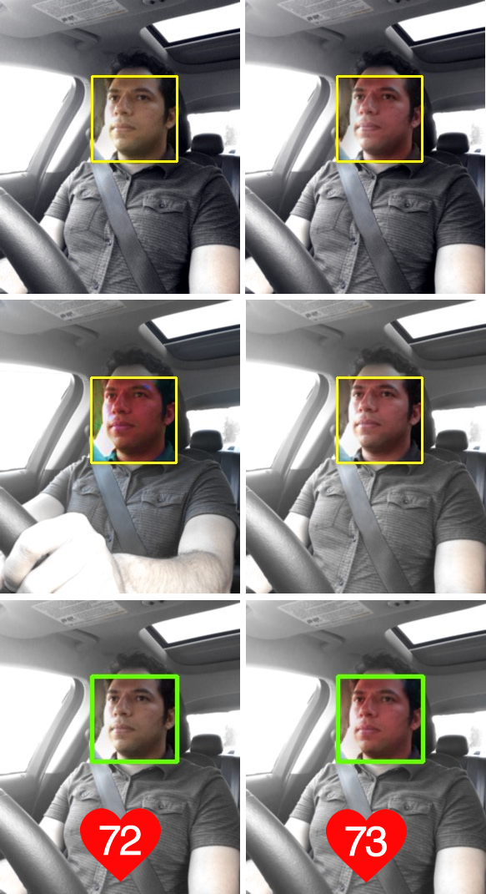

Figure Image sequence from the iOS application. First, the face detection algorithm extracts a region covering the face of a person of interest. This region is used to analyzed small changes, that latter are correlated to heart bits as displayed in the last row.

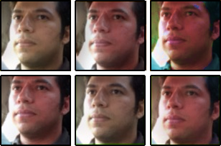

Figure Sequence of captured images after change amplification has been applied. Notice how the red intensity on the face is increasing its saturation from in the top row, and how its saturation is decreasing after reaching its peak on the bottom row.

The input of the algorithm at each time instant k, with a sampling rate of 20 frames per second, is a vector xk = [Ik, Ik-1, Ik-2 … Ik-399], where Ik is the current 352 x 288 camera snapshot. The output of the algorithm is the heart rate estimation, ŷk.

In order to compute the accuracy of the application we use a Polar H1 Bluetooth heart rate monitor as ground truth device (See Figure 6). According to the official technical specifications, the referred device has accuracy of ± 1% or ± 1 bpm, whichever larger [16].

Although the heart rate is estimated 20 times per second, the data are collected every 1 second to match the Bluetooth monitor’s update rate. The vector rk = [yk, ŷk] contains, respectively, the measured heart rate, yk, and the estimated heart rate, ŷk, at the time instant k. The estimation error is, thus, given by ek = ŷk -yk.

Experimental Results

For the experimental results, we used as a ground-truth (GT) the measured heart rate from a chest strap heart monitor described in the previous section. Measurements from GT were compared against the heart rate estimation of our algorithm over a period of time. Figure 7 shows this comparison over 140 seconds of data capture, that is a total of 2800 frames. Notice that no heart rate values were computed in the initial 20 seconds due to the sample rate chosen?.

Error estimation ek was then computed after the period of 20 seconds of stabilization as illustrated in Figure 8. Positive ek indicated an overestimation of the hearth rate that is showed to reach a maximum of ~2 bpm. Whilst negative ek, indicates an underestimation of the heart rate, reaching as low as ~-5.5 bpm. Figure 9 shows the absolute error estimation, as well as the absolute mean of the absolute error computation over this experiment. Overall our method achieves ~1.4 bpm mean error.

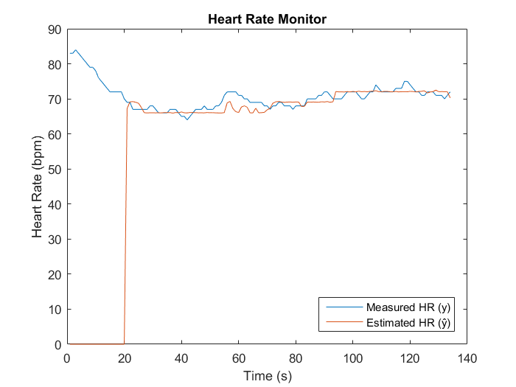

Figure 7. Comparison of HRM in bpm between our estimated method (in red) and the measured heart rate from a chest strap with transmitter (in blue). The experiment was performed during a period of 140 seconds while a person was static in front of the camera. Notice that initially an offset of 20 seconds is necessary to perform the first estimation correctly.

Figure Left, Polar H1 Bluetooth heart rate monitor used as ground truth for these experiments. Right, Illustration of the device setup, making contact with user’s chest.

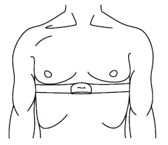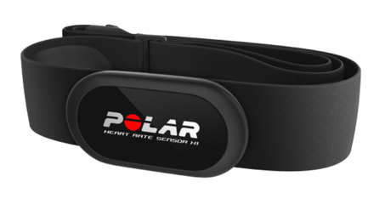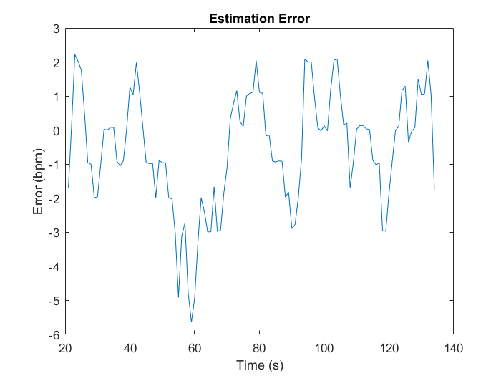

Figure Error estimation in bpm between the measured heart rate from the chest strap sensor and the estimated heart rate from our method.

Summary/Conclusions

We have demonstrated an implementation of a non-invasive technology based on a single camera to measure the user’s heart rate in real time. Our algorithm estimates the heart rate based on facial color changes from RGB images. The signal spectrum from color changes are temporally extracted using a temporal DFT, and heart beats are further processed after applying a band-pass filter. The resulted signal in the frequency domain is recovered after applying the IDFT. For image visualization, we amplify those changes caused by the heart beats by saturating the red values of intensities on the images. The proposed algorithm was implemented in real time using the iOS platform in a smartphone, with a friendly user interface offering flexibility and portability. Our experimentation results show on average a 1.4 bpm of error when compared to standard heart rate monitor.

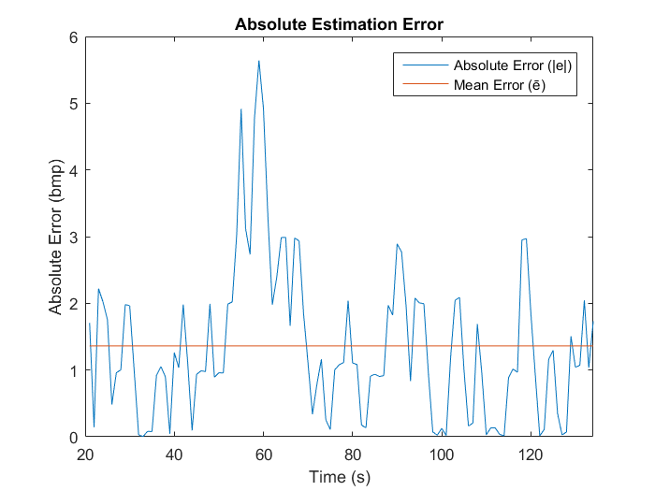

Figure Absolute error estimation |e| and mean error in bpm between the chest strap sensor and the estimated heart rate from our method. Both |e| and, are computed after a 20 seconds period necessary for our method to stabilized.

Although the method showed very good performance in our experiments, further research and development is needed for high dynamic situations where the user is constantly moving or where strong illumination changes are present. This work offers a lot of potential for future applications involving not only the computation of heart beats. For example by performing a temporal analysis of heart rates a correlation with behaviors or medical conditions such stress or potential of strokes can be inferred. An early detection of these behaviors can potentially reduce the likelihood of fatal accidents due to medical conditions while driving.

References

|  |  |
| --- | --- |
| [1] | C. f. D. C. a. P. (CDC), "Heart Disease Facts," [Online]. Available: http://www.cdc.gov/heartdisease/facts.htm. |
| [2] | S. C. Health, "Sudden infant Death Syndrome (SIDS)," [Online]. Available: http://www.stanfordchildrens.org/en/topic/default?id=sudden-infant-death-syndrome-sids-90-P02412. [Accessed 28 09 2016]. |
| [3] | R. D. a. M. K. a. R. E. M. a. C. a. e. a. Lane, "Neural correlates of heart rate variability during emotion," *Neuroimage,* vol. 44, pp. 213--222, 2009. |
| [4] | H. M. G. L. F. J. V. E. S. M. J. C. E. C. L. F. a. D. L. Tsuji, ""Impact of reduced heart rate variability on risk for cardiac events The Framingham Heart Study."," *Circulation,* vol. 94, no. 11, 1996. |
| [5] | J. Allen, " "Photoplethysmography and its application in clinical physiological measurement."," *Physiological measurement ,* vol. 28, no. 3, 2007. |
| [6] | C. V. M. L. O. B.-L. a. J. L. Li, ""A review on recent advances in Doppler radar sensors for noncontact healthcare monitoring."," *IEEE Transactions on microwave theory and techniques ,* vol. 61, no. 5, 2013. |
| [7] | A. D. Droitcour, "Non-contact measurement of heart and respiration rates with a single-chip microwave doppler radar.", PhD diss., Stanford University, 2006. |
| [8] | H. M. Z. K. e. a. Fadel Adib, "Smart Homes that Monitor Breathing and Heart Rate," in *Proc. of the ACM Conference on Human Factors in Computing Systems*, New York, 2015. |
| [9] | F. H. M. Z. K. D. K. a. R. C. M. Adib, ""Smart homes that monitor breathing and heart rate."," *In Proceedings of the Annual ACM Conference on Human Factors in Computing Systems,* pp. 837-846, 2015. |
| [10] | J. D. N. S. C. P. e. a. I. Pavlidis, "“Interacting with Human Physiology"," *Computer Vision and Image Understanding,* pp. 150-170, 2007. |
| [11] | R. G. Gatto, “PhD Thesis: Estimation of Instantaneous Heart Rate using Video Infrared Thermography and ARMA Models", University of IIIinois at Chicago, 2009. |
| [12] | A. T. W. F. F. D. e. a. C. Liu, "Motion Magnification," *ACM Trans. Graph.,* 2005. |
| [13] | D. L. a. Y. W. A. Levin, "A closed-form solution to natural image matting.," *IEEE Transactions on PAMI,* vol. 30(2), pp. 228-242, 2008. |
| [14] | M. R. E. S. J. G. F. D. a. W. T. F. H.-Y. Wu, "Eulerian video magnification for revealing subtle changes in the world," *ACM Trans. Graph. ,* 2012. |
| [15] | M. H. F. D. a. w. T. F. Mohamed A. Elgharib, "Video Magnification in Presence of Large Motion," in *Proc. of the IEEE Conf. on Computer Vision and Pattern Recognition*, 2015. |
| [16] | "Polar Move User Manual," Polar, [Online]. Available: http://support.polar.com/e_manuals/Move/Polar_Move_user_manual_English/ch05.html. [Accessed 30 09 2016]. |

Contact Information

Dongran Liu, [dliu64@ford.com](mailto:dliu64@ford.com)

Yi Zhang, [ychang336@ford.com](mailto:ychang336@ford.com)

Bruno Jales Costa, [bcosta17@ford.com](mailto:bcosta17@ford.com)

Marcos P. Gerardo-Castro, [mgerard8@ford.com](mailto:mgerard8@ford.com)

All authors are affiliated with Ford Research & Innovation Center Palo Alto (RICPA), 3200 Hillview Ave, Palo Alto, CA 94304. [Phone](https://www.google.com/search?q=ford+research+%26+innovation+center+phone&stick=H4sIAAAAAAAAAOPgE-LVT9c3NEwyqywyqkou19LPTrbST87PyUlNLsnMz9PPzssvz0lNSU-NL0jMS80p1s9ILI4vyMjPS7UCkwAedWUNQgAAAA&sa=X&ved=0ahUKEwi8o-fR8rfPAhVJGh4KHZCVDhMQ6BMIiAEwDw): [(650) 646-6830](javascript:void(0)).

Acknowledgments

If the Acknowledgments section is not wanted, delete this heading and text.

Definitions/Abbreviations

|  |  |
| --- | --- |
| SIDS | Sudden infant Death Syndrome |
| HRMs | Health Rate Monitor. |
| HRVs | Health Rate Variability. |
| ECG | Electrocardiography. |
| OHM | Optical Health Monitoring. |
| PPG | Photoplesthysmography. |
| DFT | Discrete Fourier Transform. |
| IDFT | Inverse Discrete Fourier Transform. |

Appendix

The Appendix is one-column. If you have an appendix in your document, you will need to insert a continuous page break and set the columns to one. If you do not have an appendix in your document, this paragraph can be ignored and the heading and section break deleted.